1-Anne etini tat.
2-Nil taneli al.
3-Nalan eline tel al.
4-Altan attan in.
5-Ata telli at.
6-Ata annene et.
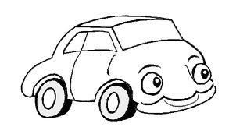
7-Lale enli atlet al.
8-Nil itele..
Anne | tel | al. | in | Ata
tat |  | AltanNn | attan | telli
al. | eline | Nalan eline tel al. |  | at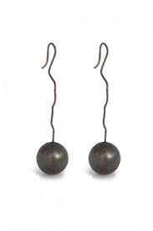
etini | Nil | nanelii | Ata | 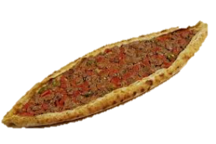
annene |  | et. | Lale | enli
atlet | al. | Nil |  | itele
Adım : Numaram:
1
2
3
4
8
7
6
5

