**R SESİ ÇALIŞMA SAYFASI**

C:\Users\eymen\AppData\Local\Microsoft\Windows\Temporary Internet Files\Content.IE5\9K6RC6R8\MC900217540[1].wmfC:\Users\eymen\AppData\Local\Microsoft\Windows\Temporary Internet Files\Content.IE5\RR356995\dglxasset[3].aspx 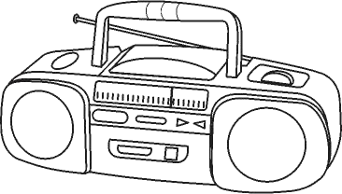

R r

Rrrrrrrrrrrr

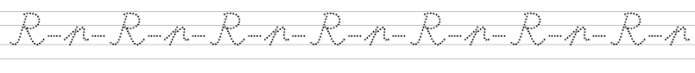



**Seslerinin üzerinden gidiniz ve boşlukları tamamlayın.**

r r r r r r r r r r r r r

r r

r r

rr

rr

rr

R R R R R R R R R R R

RR

R

R

R

El el al il ol et at it ot en an in on er ar ir or

Le le la li lo te ta ti to ne na ni no re ra ri ro

Metinleri 10 kere oku üstünden giderek yaz

|  |  |
| --- | --- |
| Taner nar ara. | Taner nar ara. |
| Taner nar al. | Taner nar al. |
| Erol nar al. | Erol nar al. |
| On tane al. | On tane al. |
| İri iri nar al. | İri iri nar al. |
| Eren olta al. | Eren olta al. |
| Rana olta at. | Rana olta at. |

|  |  |
| --- | --- |
| Ali o attan in. | Ali o attan in. |
| Ali ata ot at. | Ali ata ot at. |
| Erol ata ot at. | Erol ata ot at. |
| Taner on lira al. | Taner on lira al. |
| On tane images al. | On tane images al. |
| Onat images tat. | Onat images tat. |
| Eren images tat. | Eren images tat. |

Erol

Rana anneni………ile ara.

nar

Eren on tane…………al.

tere

Taner et ile ………….tat.

Rana

ar

Rana nar al.

Rana iri iri nar al.

ra

Rana on lira al.

On tane iri nar al.

re

er

Erol

Erol at otlat.

ir

Erol at otlat.

Erol inek otlat.

ri

ro

Eren

or

Eren olta al.

On olta al.

er

Olta ile  al.

Eren ala  .

renn

Eren  tat.

Eren eti 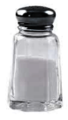 ile tat.

Metinleri 10 kere oku bakmadan dikde defterine yazyaz