RESİMLİ DİKTE ÇALIŞMASI

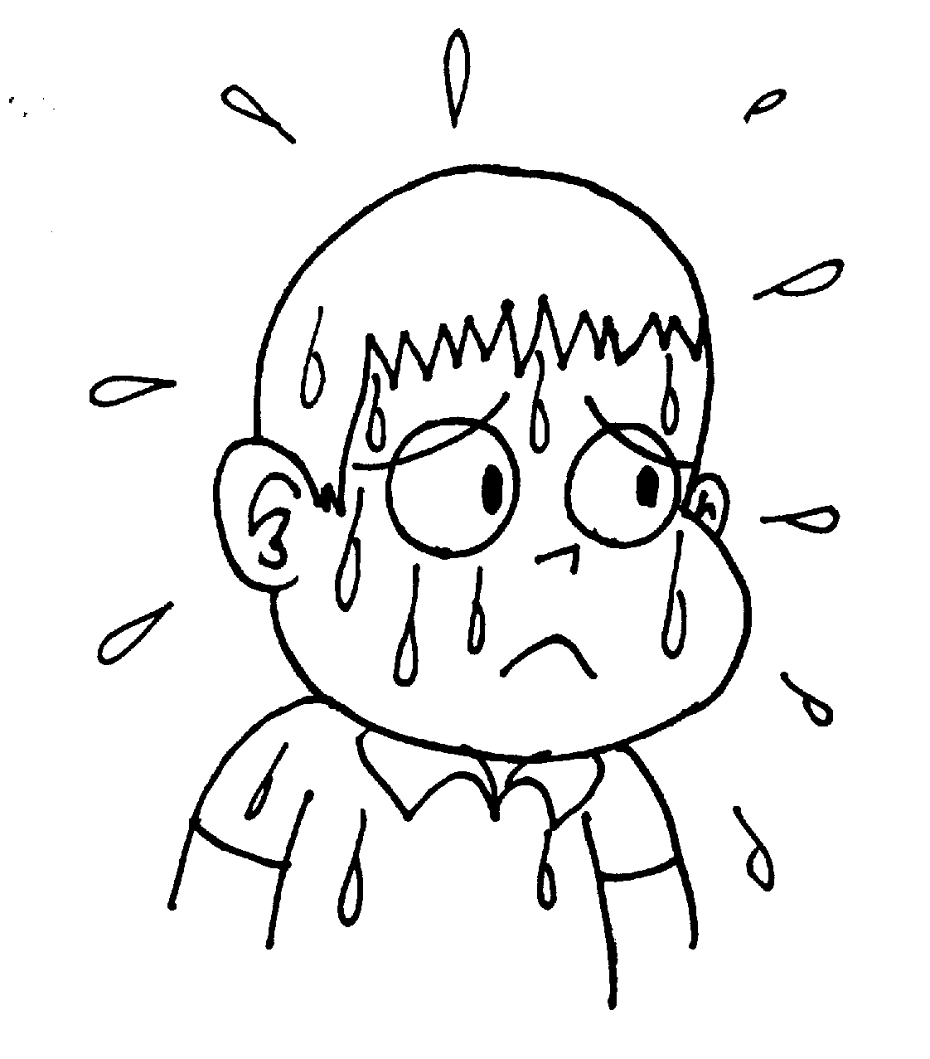

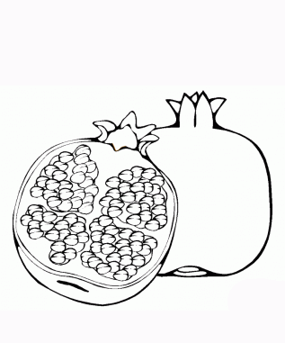

|  |
| --- |
|  |
|  |
|  |

|  |
| --- |
|  |
|  |
|  |

|  |
| --- |
|  |
|  |
|  |

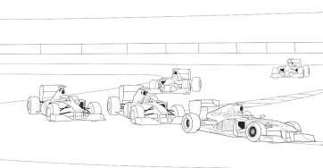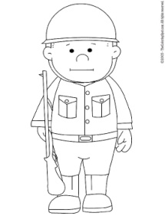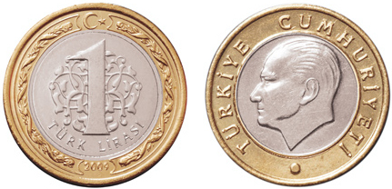

|  |  |  |  |  |
| --- | --- | --- | --- | --- |
|  |  |  |  |  |
|  |  |  |  |  |
|  |  |  |  |  |

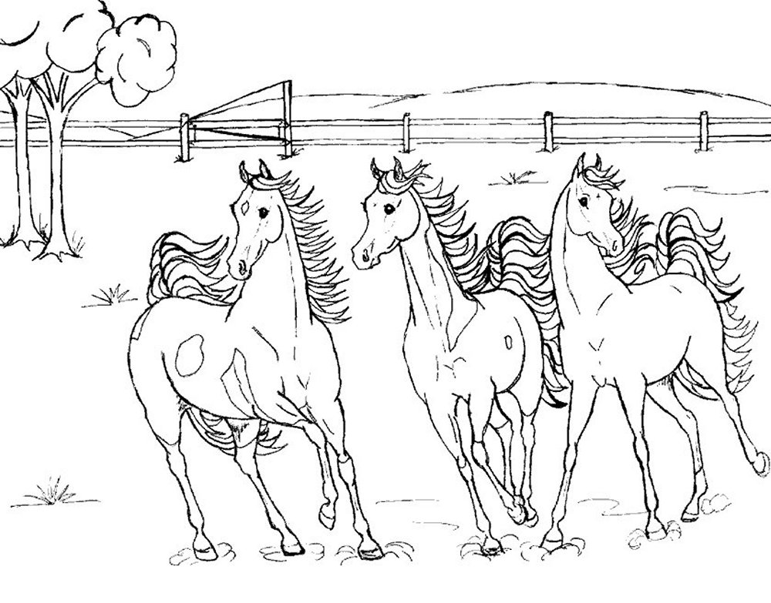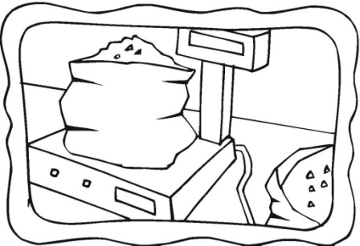

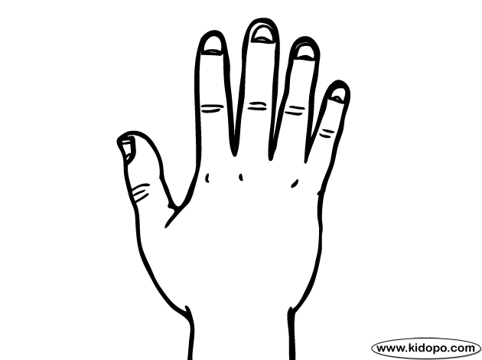

|  |  |  |  |  |
| --- | --- | --- | --- | --- |
|  |  |  |  |  |
|  |  |  |  |  |
|  |  |  |  |  |

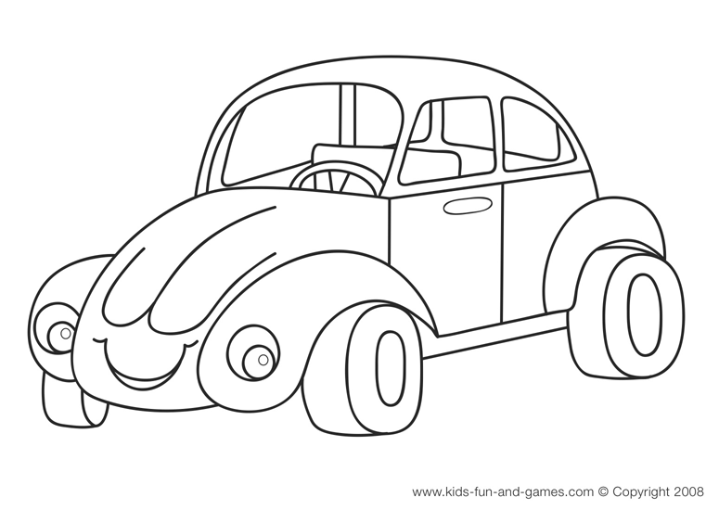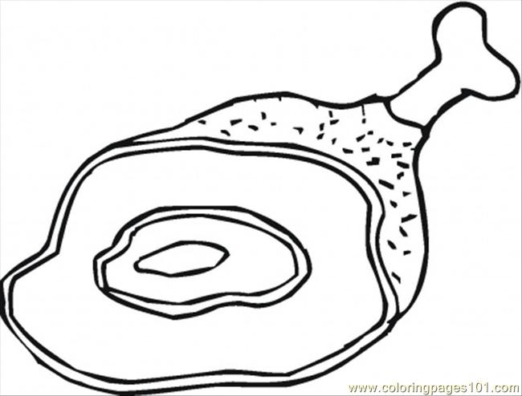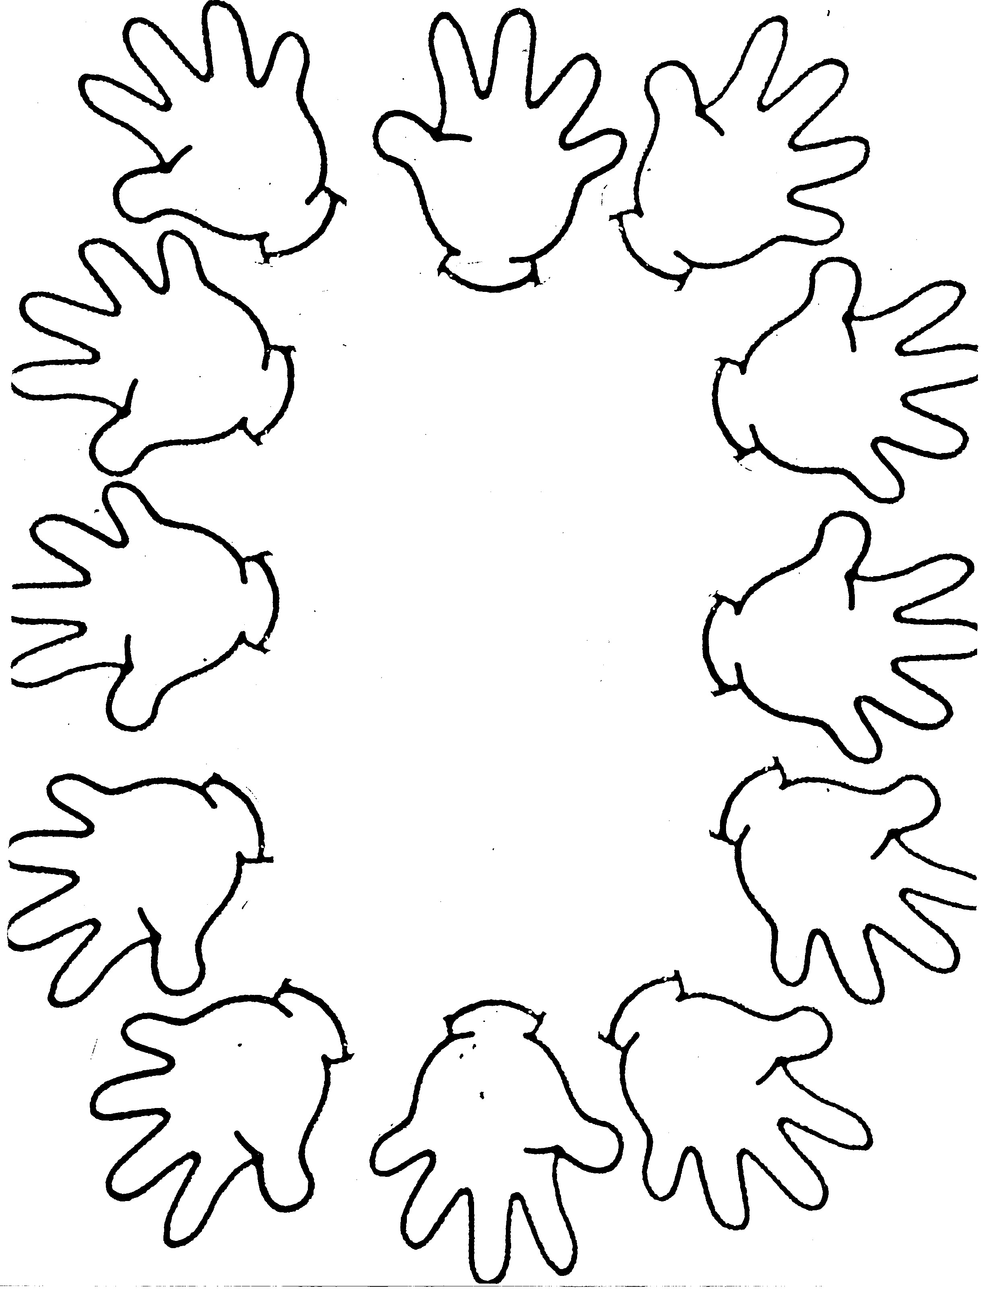

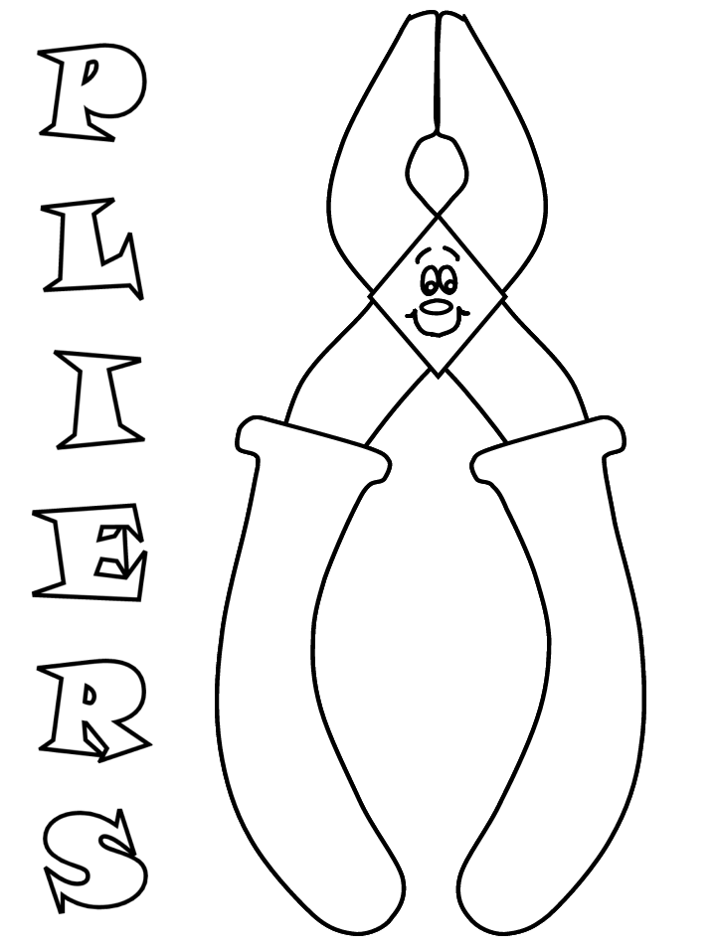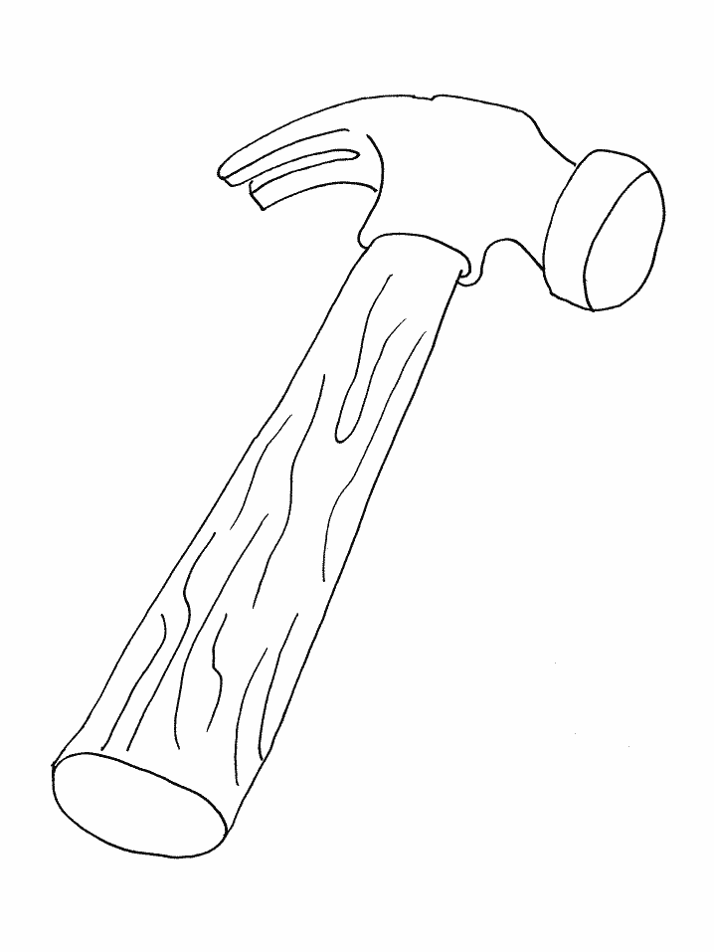



|  |  |  |  |  |
| --- | --- | --- | --- | --- |
|  |  |  |  |  |
|  |  |  |  |  |
|  |  |  |  |  |

Resimler: terli-nar-ara-lira-er-ralli-tart-atlar-tara-eller-etler-otolar