[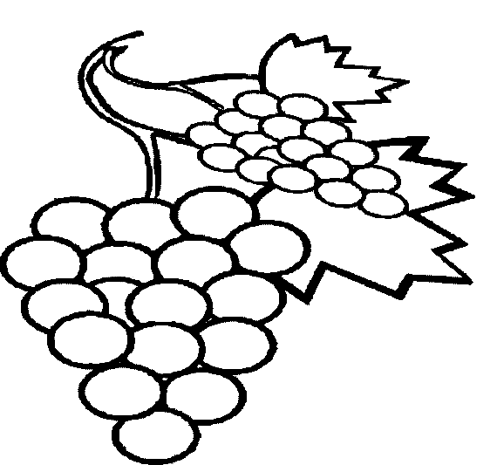](http://www.google.com.tr/url?sa=i&rct=j&q=&esrc=s&source=images&cd=&cad=rja&uact=8&ved=0ahUKEwibu_KAm47KAhWJ6xoKHWyLBTsQjRwIBw&url=http://www.boyamalar.com/uzum-2-boyama-sayfasi/&bvm=bv.110151844,d.bGg&psig=AFQjCNHKq9S0qAsKntcQDH-wV0lSfmYYmA&ust=1451930027246186) [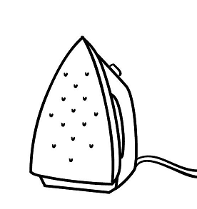](http://www.google.com.tr/url?sa=i&rct=j&q=&esrc=s&source=images&cd=&cad=rja&uact=8&ved=0ahUKEwiIq4efm47KAhWCLhoKHapdCIoQjRwIBw&url=http://www.boyamasayfalari.net/tasarruf-boyama-sayfasi/&bvm=bv.110151844,d.bGg&psig=AFQjCNGZnHIKco_0USVVElak2T1pAlNe4g&ust=1451930093941837)[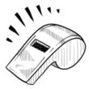](http://www.google.com.tr/url?sa=i&rct=j&q=&esrc=s&source=images&cd=&cad=rja&uact=8&ved=0ahUKEwiE8YfLnI7KAhWL1xoKHYB_BDkQjRwIBw&url=http://de.depositphotos.com/13851126/stock-illustration-pushkin-with-a-whistle.html&bvm=bv.110151844,d.bGg&psig=AFQjCNGr2d7a2mUx5jgMEQv0jKzvkqN1Aw&ust=1451930456235818)[](http://www.google.com.tr/url?sa=i&rct=j&q=&esrc=s&source=images&cd=&cad=rja&uact=8&ved=0ahUKEwj1-_yRm47KAhVCOBoKHf8TCasQjRwIBw&url=http://nazarca.com/cok-sirin-cocuk-resimli-rakam-ogrenme-boyama-sayfalari/sevimli-rakam-boyama-resimleri-okul-oncesi-nazarca-3&bvm=bv.110151844,d.bGg&psig=AFQjCNENsxGPG6KhyJedyDNLjbMPnqHR7Q&ust=1451930065401916)

üç düdük üzüm ütü

[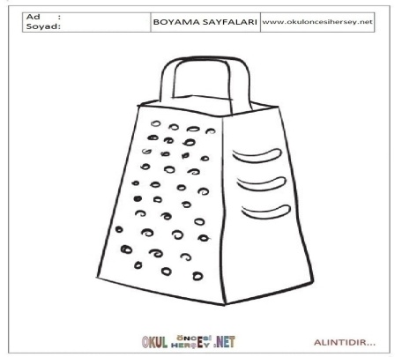](http://www.google.com.tr/url?sa=i&rct=j&q=&esrc=s&source=images&cd=&cad=rja&uact=8&ved=0ahUKEwje1566m47KAhUCrxoKHWXGBn4QjRwIBw&url=http://www.okuloncesihersey.net/boyama-sayfalari-esyalar-Rende-3.html&bvm=bv.110151844,d.bGg&psig=AFQjCNEMyuPo6_TSyjdKflpV0teND4zeiw&ust=1451930137556707)[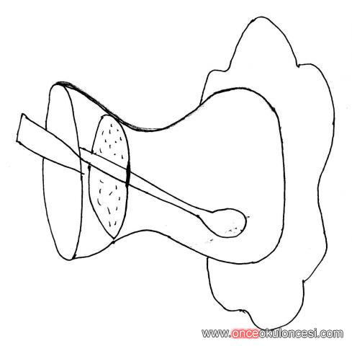](http://www.google.com.tr/url?sa=i&rct=j&q=&esrc=s&source=images&cd=&cad=rja&uact=8&ved=0ahUKEwjpzrahnI7KAhVBoRoKHZNzCtAQjRwIBw&url=http://www.onceokuloncesi.com/545521-post19.html&bvm=bv.110151844,d.bGg&psig=AFQjCNGkLuNExqbIntVOMGqwckAK-nioYQ&ust=1451930328660759)[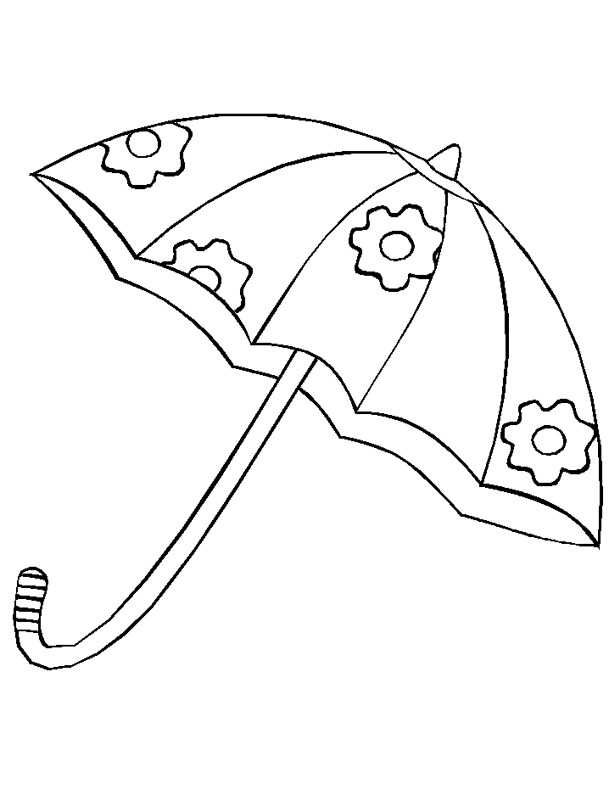](http://www.forumkisa.com/boyama-isleri-cizimler/49263-semsiye-boyama-resimleri.html)[](http://www.google.com.tr/url?sa=i&rct=j&q=&esrc=s&source=images&cd=&cad=rja&uact=8&ved=0ahUKEwjbucejnY7KAhWFOxoKHSYCAncQjRwIBw&url=http://www.bilgilersitesi.com/okul-oncesi-dis-boyama-etkinlikleri-boyama-sayfalari-resimleri.html&bvm=bv.110151844,d.bGg&psig=AFQjCNEB8GgAgC7MSIcaEFVkKdVEOzuIcA&ust=1451930641291974)

şemsiye rende diş bardak

[](http://www.google.com.tr/url?sa=i&rct=j&q=&esrc=s&source=images&cd=&cad=rja&uact=8&ved=0ahUKEwjv6bHinY7KAhXGLhoKHVX1Aa0QjRwIBw&url=http://www.bilginim.com/sevimli-meyve-sebzeler-boyama-sayfasi/muz-boyama-sayfasi-2/&bvm=bv.110151844,d.bGg&psig=AFQjCNFXIOn_wWvQZSBG0shYpybsf6ixZA&ust=1451930768730788)[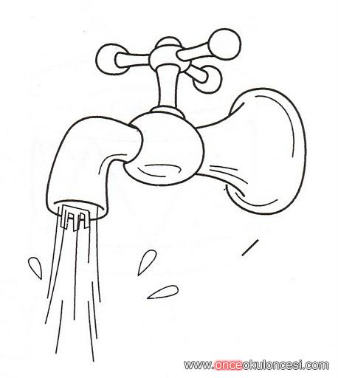](http://www.google.com.tr/url?sa=i&rct=j&q=&esrc=s&source=images&cd=&cad=rja&uact=8&ved=0ahUKEwiuor_2nY7KAhWJXRoKHZH7BeYQjRwIBw&url=http://www.onceokuloncesi.com/enerji-tasarrufu-etkinlikleri/musluktan-akan-su-91373.html&bvm=bv.110151844,d.bGg&psig=AFQjCNEgrhY5Je17-NuBmSWr5rmTTFzHnw&ust=1451930816328178)[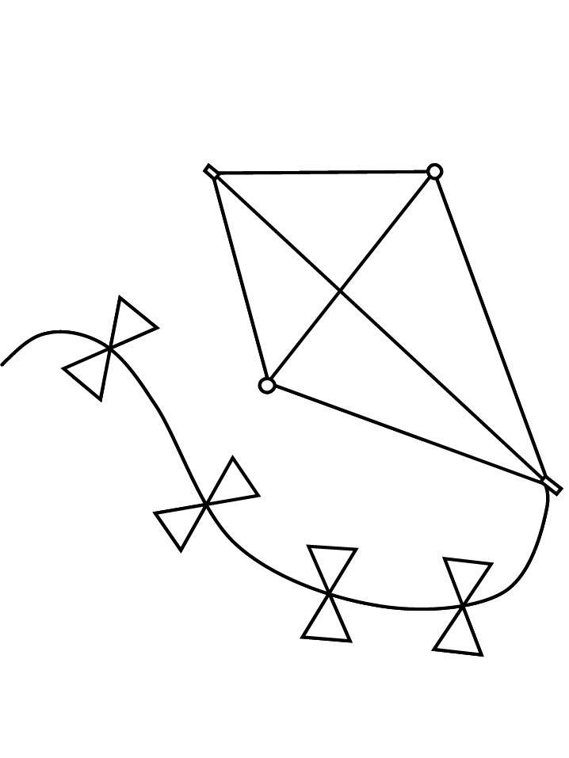](http://www.google.com.tr/url?sa=i&rct=j&q=&esrc=s&source=images&cd=&cad=rja&uact=8&ved=0ahUKEwijr_mcno7KAhVDWhoKHc8sDfUQjRwIBw&url=http://www.bilginim.com/ilkbahar-boyama-sayfalari/free-kid-coloring-kite/&bvm=bv.110151844,d.bGg&psig=AFQjCNGYXN98xoxu7GomiLNc6fHNoNeI4Q&ust=1451930895014695)[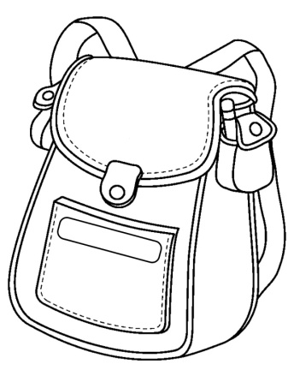](http://miniminiyiz.com/okul-cantasi/)[](http://www.google.com.tr/url?sa=i&rct=j&q=&esrc=s&source=images&cd=&cad=rja&uact=8&ved=0ahUKEwjx95Gwn47KAhXHbBoKHURRDgsQjRwIBw&url=http://okuloncesingilizce.blogspot.com/&bvm=bv.110151844,d.bGg&psig=AFQjCNGTgmUKKL-5Dme7I7CK6AAnOUH43Q&ust=1451931182276179)

çeşme muz çanta çilek uçurtma